CHAPTER II

PROJECT CHARTER

This chapter includes the statement of the scope, objectives, and participants in the team’s proposed system. It provides a preliminary delineation of roles and responsibilities, outlines the project objectives, identifies the main stakeholders, and defines the authority of the project manager. The following are also included in the project charter: project conception, project vision, business and technology constraints, project strategy, project documentation and communication, and project organization and staffing.

2.1 Project Objectives

In this study, the team formulated the objectives that help improve the current operation of the Inter-Pacific Study and Migration Consultancy. These objectives describe the outcome of the team’s system for the organization. The objectives of the study are as follows:

2.1.1 Generate a Printable Reports

The system helps the organization in producing fast and accurate reports that are needed immediately. With the help of the system the user does not need to manually provide or write the reports needed, the system eventually does it for the user based on the user’s needs. The user also specifies the date and the type of report that is needed.

2.1.2 Provide an Electronic Copy of Documents for the Company

The system provides the organization an electronic copy of documents for all the data and information they gather from their clients. With the help of the storage provided by the system, the organization eliminate data anomalies in their data and information.

2.1.3 Provide Monitoring of Student

This system helps them contact their both clients to know their status outside the country. For student client, the admin asks them if there are some concerned based on their study outside the country.

2.2 Project Conception

The team decided to work on this study so that the team could be able to document and develop a system that would benefit the organization. The team conducted interview to the employees as well as to the manager of the said company and because of that, the team gather information about their processes, services, other data related to their different services and of what problems they are experiencing. Through this information, the group develop ideas and came into a decision on what system the team be working that would best fit the organization’s needs. The team’s reason for automating the processes is that the group wanted to improve the productivity of the company and provide or increase its efficiency. In terms of technology, the company has the readiness, capability, and is willing to adapt the system since the group already discuss to them how the system improve their company productivity and since they are already familiar to some of the technologies that exist on generation of today.

Once the system is implemented in the organization, the team foresee that it helps the organization in its processes and transactions. The organization benefit well through the different modules designed and incorporated in the proposed system. Manual processes now be automated for faster and easier transactions.

2.3 Problem Statement

After a thorough study and analysis of the business process, the group was able to identify problems faced by the organization. Generally, the organization encounters input, processing and report generation. Specifically, the group was able to identify the following problems:

2.3.1 Slow Generation of Reports

During the interview, the team identify that the organization has a problem in the generation of their reports since they do not have a stable system that would cater their needs. Processes in the organization is purely manual so the consultant have a hard-time to give out reports that is needed.

2.3.2 Organization has No Electronic Copy of Documents

Another problem in the organization is that they do not have a database storage to store the data and information gathered from their clients. This problem likely to result in data anomalies since there be no storage to properly validate data inputs.

2.3.3 Difficulty in Monitoring Students Abroad

In monitoring the students sent to abroad for school purposes, the organization have a hard-time since they only use e-mails and social media to communicate with the students. Some students do not reply to e-mails sent by the organization.

2.4 Initial Scope of the Project

The type of system that the team develop is an Information System for Inter-Pacific Study and Migration Consultancy. As an Information System, its main purpose is to store information about the different clients the organization have based on the different services they have. The system focusses on the Student and Tourist Visa application, the matching of students to different overseas schools associated with the organization, and the online monitoring of students. All the information gathered from the clients be store in the system database to secure its confidentiality.

This is the context data flow diagram Inter – Pacific Study and Migration Consultancy Information System.

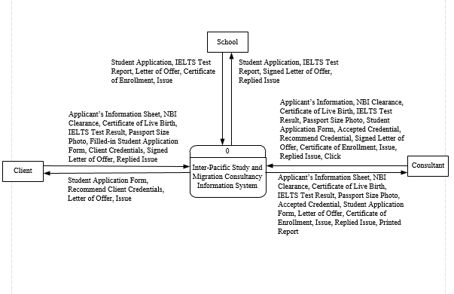

Figure 7. Context Data Flow Diagram of Inter-Pacific Study and Migration Consultancy

Information System.

The first explosion of Inter – Pacific Study and Migration Consultancy Information System which is shown in Figure 8 is the overall process of the system. The first process is the application of visa both tourist and students. The second process is the matching which cater the transaction process of the company for their clients. The third process is the monitoring of students who was already approve by the company and currently taking their course abroad. Lastly, the process of how the system can generate reports for the company and clients purposes.

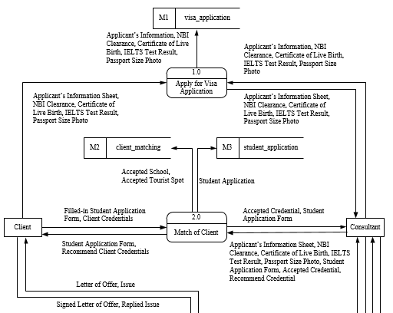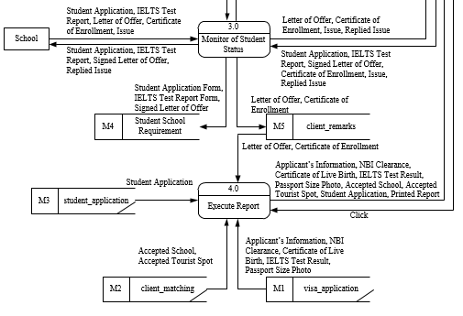

Figure 8. First Explosion Diagram of Inter-Pacific Study and Migration Consultancy

Information System.

The second explosion of the first process which is apply for visa application.

Figure 9. Second Explosion Diagram of Inter-Pacific Study and Migration Consultancy

Information System – Apply for Visa.

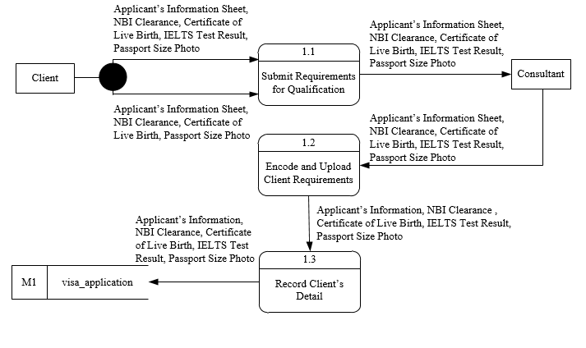

The second explosion of the second process which is match of student and tourist.

Figure 10. Second Explosion Diagram of Inter-Pacific Study and Migration Consultancy

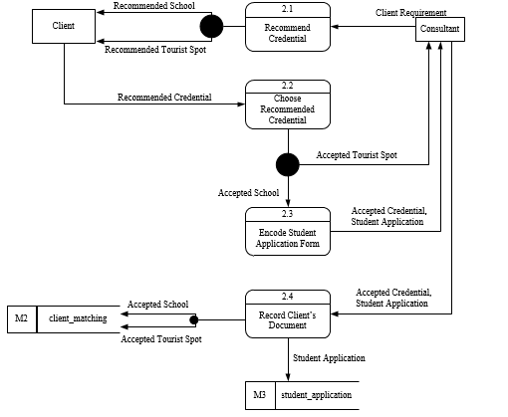

Information System – Match of Student and Tourist.

The second explosion of the third process which is monitor the student status.

Figure 11. Second Explosion Diagram of Inter-Pacific Study and Migration Consultancy

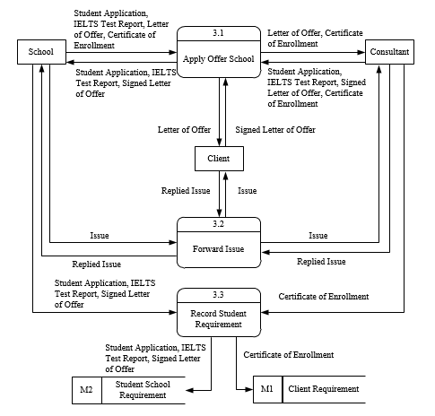

Information System – Monitor Student Status.

The third explosion of the 1.1 which is the walk-in process.

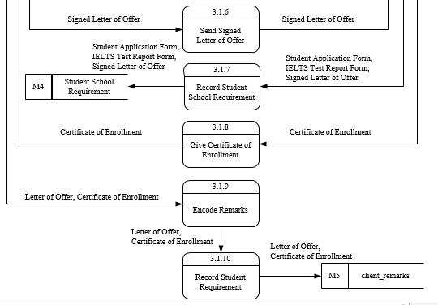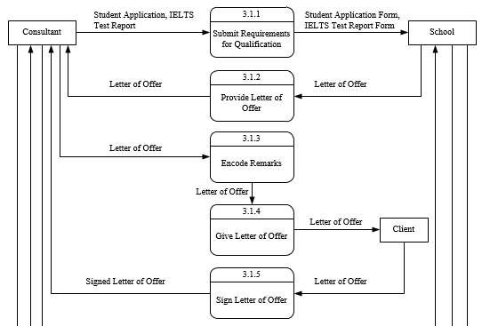

Figure 12. Third Explosion Diagram of Inter-Pacific Study and Migration Consultancy

Information System – Walk-in Process.

The third explosion of the online process.

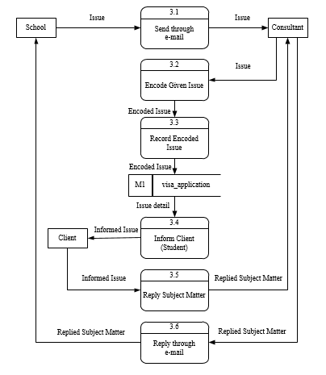

Figure 13. Third Explosion Diagram of Inter-Pacific Study and Migration Consultancy

Information System – Online Process.

Figure 14 shows the process of generating a reports. It includes all the detailed and summary reports.

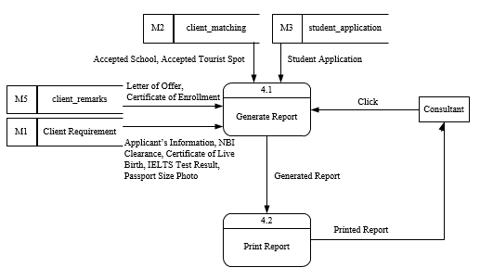

Figiure 14.Third Explosion Diagram of Inter-Pacific Study and Migration Consultancy

Information System – Report Generation..

2.5 Project Vision

As an information system, the system is expected mainly to improve the organization processes in the processing of visa for their different clients as well as the monitoring of the students they send in their partner schools abroad. The following are the improvements the system is expected to do once it is implemented: it improve the migration processes so that the organization have the time to properly checked the documents needed by their clients to get a visa for a specific purpose, next is to provide the organization a database for the storage of the data and information they get from their clients, with the use of database the information gathered be secured and prevent data anomalies in the organization, and lastly the system help the organization to monitor the students they send to their partner schools abroad.

2.6 Business Constraints

The team’s system focuses on the scope of Student and Tourist Visa application, matching of students to different schools abroad that are associated with the organization – to help the students choose the schools to which he or she enroll and what program of study is applicable to his or her skills, achievements, and educational background. The system also caters the monitoring of students from different schools abroad to help the organization of being updated of the status of the students they sent there.

For students, they need to get an application form first in the organization and provide all the needed requirements and documents. They are also required to attend IELTS review and take IELTS examination. They need to wait for the confirmation of the school the organization contacted for them to study abroad. When students are on abroad the organization keeps of monitoring them to know their status in school as well on the country. On the other hand, for tourist, they need to go the organization and fill-up the application for tourist visa. They also need to provide necessary documents and requirements. The visa being given to tourist only last for the span upon the request of the client.

2.7 Technology Constraints

Basically, the team’s system be on a web-platform basis since the organization need to monitor and contact students abroad. The organization could also connect the system to the different embassy they are associated with so that it would be easy for them to forward information about the clients for visa application purposes.

The team might as well use the following tools stated below in the development stage of the system:

* Photoshop – for editing images that be use for the system interface.
* Microsoft SQL Server – serve as the storage of the data and information being gathered by the organization.
* PHP – serve as the programming language to be use.
* PHPDesigner 8 – platform to be used for the php programming language.

2.8 Project Strategy

The system development methodology is used to describe the process of building systems, intended to develop the system in a very thoughtful, structured and systematic way. Throwaway prototyping is a method of development that employs technical mechanisms for reducing risk in a project. The methodology allows the proponents deliberately to decide in building out a set of functionalities for an application, or in building out the entire prototype application to explore fully what it is that the proponents are trying to accomplish and ensuring that every feature and functionality is in the line with the objectives of the system.

2.9 Project Documentation and Communication

The team’s documentation was based on the data gathered from informal and formal interview, as well as investigation and observation. At first it is hard on the team’s part to collect or gather data from the organization because of its confidentiality but with further interviews and all we got the needed data for the documentation. The problems with the organization were identified by the team with the help of the employees in the said organization. The team identified the effects of the said problems to the organization. Slow generation of reports, inaccurate and outdated inventory monitoring, and unsecured data are the problems. These problems provoked the team to develop a system that help and is best suited for the organization.

2.10 Project Organization and Staffing

The staffing of the team’s proposed system be based of the team’s chosen approach. The team delegate the activities properly. The team use the work breakdown structure in dividing the task so that it provides the team with the basis for planning and managing project schedules, costs, resources and changes. It also helps the team in defining the total scope that be included in the project. Each person be assigned a task to the field of his or her specialization with a corresponding amount of time. Finally, the team incorporate the tasks they have worked on.